Group 3 - Designers
Problem Statement: To assess speaking skills of class 8 students for the year 2026-27
Empathy | Students | Teachers | Methods
 | Nervousness, anxiety, stage fear, peer pressure, language barrier, limited vocabulary | Am I able to assess speaking skills in a fair and structured way?  Am I giving equal opportunity to students?  Am I creating supportive environment that encourages participation? | - Observations  - Surveys  - Interviews  - Peer Interactions
Define | Real challenge: Lack of practice and timely feedback are the main causes of low performance in speaking skills. |  | Assessment designing  1.encourages students to speak confidently and express their ideas clearly,  2. assesses spontaneity, fluency, and communication skills,  3. and provides constructive feedback while reducing fear of public speaking.P
Ideate | Brainstorm possible strategies to assess speaking skills:  - JAM (Just A Minute) speaking activity  - Short impromptu speech on given topics  - Pair discussion followed by sharing ideas  - Story continuation activity  - Picture-based speaking prompts  - Group presentation  - Debate or mini discussion rounds
Prototype | Develop a JAM Assessment Activity:  - Each student receives a simple topic or prompt.  - Students speak for one minute without hesitation or repetition.  - Teacher observes and assesses using the following rubrics.  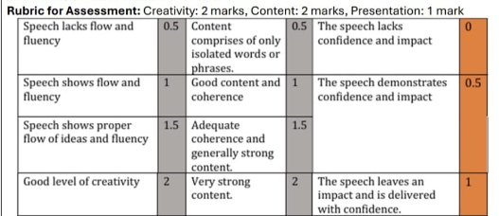  Rubrics pointers will vary as per the learner’s level.
Validate | - Conduct the JAM activity with 10 diverse groups of students.  - Collect teacher observations and student feedback.  - The teacher will check if:  - Students feel comfortable speaking.  - The time limit is appropriate.  - The rubric helps in fair assessment.  - Results will be analyzed to check the effectiveness of the tool.  - Diverse learners will be given a second chance to present again after improvements based on feedback and scores.
Implement | Based on the teacher’s observation and responses collected, the teacher will conduct JAM with the rest of the students of class 8.

